# Experiment No. 5

**Aim:** To implement functions, recursive functions and lambda functions in Python.

# Problem Statements:

1. To implement functions in Python.
2. To implement recursive functions in Python.
3. To implement lambda functions in Python.

# Questions:

1. **To implement functions in Python.**
   1. 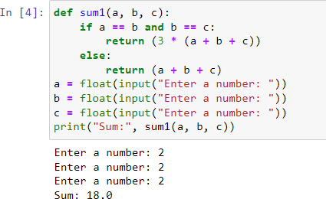Write a Python function to calculate sum of three user entered numbers, if the values are equal, then return thrice of their sum.
   2. Write a Python function to get a string which is n (non-negative integer) copies of a given string.

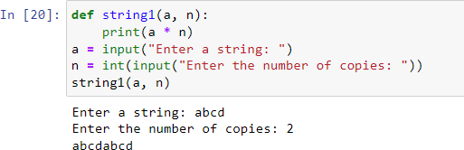

* 1. Write a Python function to find GCD of 2 numbers.

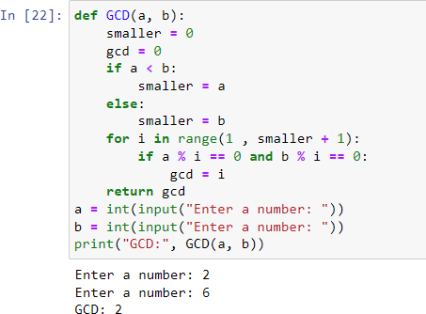

* 1. 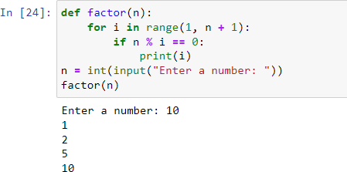Write a Python function to generate all the factors of a number.
  2. Write a Python function to find sum of digits of a user entered number.

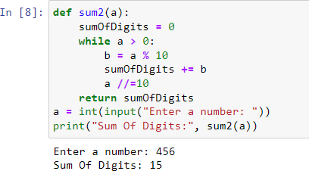

* 1. Write a Python function to concatenate two strings.

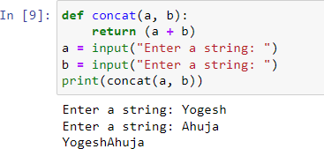

* 1. Write a Python function which takes 2 strings s1 and s2 and an integer n as arguments. The function should return True if first n characters of both the strings are same else return false.

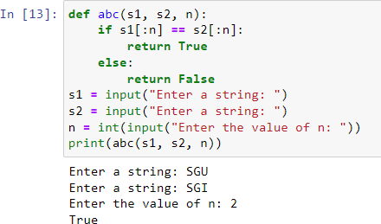

* 1. 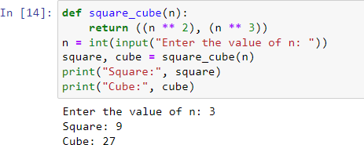Write a Return Type Python function to accept one integer number from user and return its square and cube.
  2. Write a Python function to accept a lowercase word and return its uppercase equivalent.

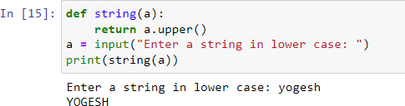

* 1. Write a Python function to which accepts radius from the user and returns area of circle. (Use predefined constant ‘pi’).

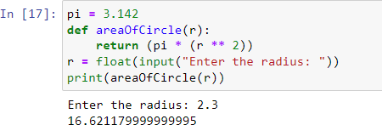

# Recursion:

* 1. 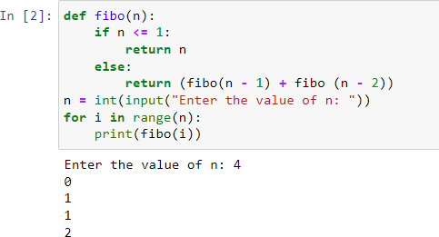Write a python function to dispaly the fibonacci series using recursion:
  2. Write a python function to find the sum of n natural numbers using recursion:

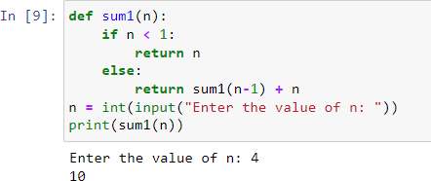

* 1. Write a python function to convert a decimal number to its binary equivalent using recursion

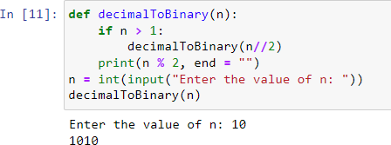

1. **Lambda**:-
   1. 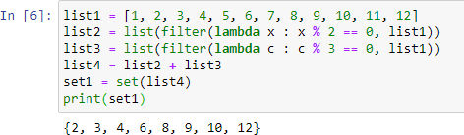Write a function to filter all multiples of 2 and 3 from the given list = [1 to 12]:
   2. Writer a program that invokes a function after specific mili seconds.

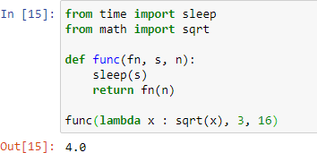

* 1. Compute factorial of 10 using lambda function (Hint: Use reduce function)

